SuperClass - Straight Line Graphs.

Arrange the seats in a 6 by 5 arrangement.
On arriving ask the students to complete the (x,y) tables.

Place on each chair the appropriate (x,y) co-ordinate.

Ask students who has the following:
- x value which = 1
- x value which = 5
- y value which = 3
- y value which = 2
- x + y = 4
- x + y = 6
- x = y
- 2x + y = 6
- y = x + 2
- y = 2x
- y = 0.5x

Ask them to hold the cord and draw out the fact that these are all examples of straight-line graphs. Illustrate these on the OHP.

On the pre-printed grids ask the students to draw and label the lines below.

Grid 1 | Y = 2 | Y = 3 | Y = 1
Grid 2 | X = 2 | X = 4 | X = 6
Grid 3 | X + Y = 3 | X + Y = 6
Grid 4 | Y = X | Y = X + 5 | Y = X +2
Grid 5 | Y = X | Y = 2X | Y = 3X
Grid 6 | Y = 0.5X + 6 | Y = 2X -3

Draw out observations.

Graphics Calculators:
Set the range using the WINDOW button. (0,10,1,1,0,10,1,1)

Enter the graphs y = 2, y = 6 and y = 3
[To delete when in the y = window press CLEAR]

Press the TRACE button and then switch between the lines by pressing the up and down arrows.

Delete them both.

Refer to grid 6. Enter y = 0.5x + 6 and y = 2x - 3
Use the trace function to find the point of intersection (6,9)
[Calculator doesn't give the exact value - why?)

Delete them both.

Ask the students to draw each of the following - show an adult before moving on to the next one. Delete lines between problems.
- Two parallel lines.
- Two lines passing through the point (0,2)
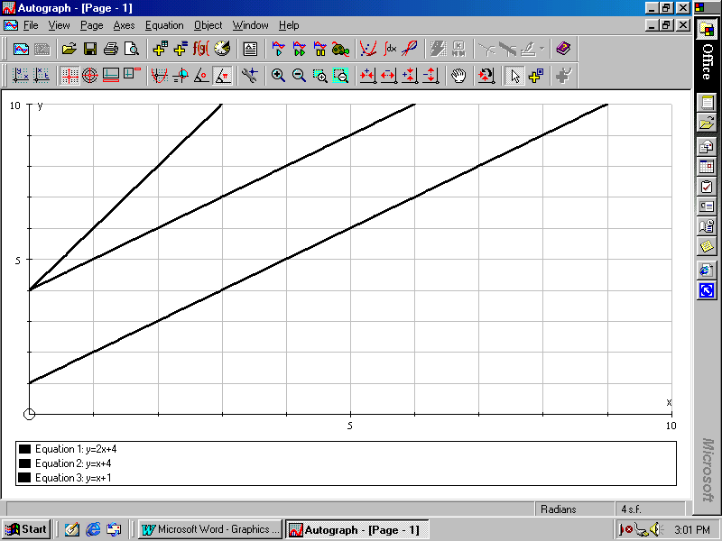
- 3 lines looking like this:

How can you draw x + y = 4? 2x + y = 6?
Draw 3 lines which form a triangle. Draw it on paper and find the area of the triangle.
Try different equations to try and maximise the area of the triangle.
SuperClass - Straight Line Graphs.

For each of the following 9 grids find 5 pairs of numbers which fit the given rule: E.g. If X + Y = 7 then X = 5 and Y = 2 would fit the equation.

X + Y = 5 |  |  | X = 4 |  |  | Y = 3
X | Y |  | X | Y |  | X | Y
Y = 2X |  |  | Y = X + 4 |  |  | Y = X
X | Y |  | X | Y |  | X | Y
2X + Y = 10 |  |  | Y = 0.5X |  |  | Y = 3X - 2
X | Y |  | X | Y |  | X | Y

